SATHIYA PRIYA S (1JT18IS051)

**Challenge Program:**

a. Add above code of text growing and shrinking.

b. Use following tags

i. Header

ii. Footer

iii. Heading tags

iv. Paragraphs

v. Sections – date and time of photo clicked.

vi. Figure – for images

vii. Article – for description of images

viii. Breaks

ix. Basic tags, etc

**Code:**

<!DOCTYPE html>

<html lang="en" dir="ltr">

<head>

<meta charset="utf-8">

<title>challenge program-3</title>

<style>

* {

box-sizing: border-box;

margin: 0;

SATHIYA PRIYA S (1JT18IS051)

padding:0;

}

body {

font-size: 19px;

}

header {

margin: 0;

}

.main {

position: relative;

margin-left: 1%;

}

.main img {

margin-left: 0%;

height: 390px;

width: auto;

}

#demo {

SATHIYA PRIYA S (1JT18IS051)

position: absolute;

margin-left:60%;

padding-bottom:200px;

transform: translate(-50%, -50%);

}

footer {

background:white;

}

footer p {

padding: 10px;

}

table{

color: darkorange;

}

</style>

</head>

<body>

<header>

<a href="#home">Home</a> |

<a href="#places">Places</a> |

SATHIYA PRIYA S (1JT18IS051)

<a href="#gallery">Gallery</a> |

<a href="#search">Search</a> |

<a href="#aboutus">AboutUs</a>|

</header>

<br>

<section class="main">

<h1>

<B>Coutrallam Falls</B>

</h1>

<br><br>

<img src=https://yatramantra.com/wp-content/uploads/2019/09/Kutralam_Falls-780x588.png "F5&F10">

<p id="demo"></p>

<br>

<p>by <U><a href="#">1JT18IS051-SATHIYA PRIYA S</a></U></p>

<br>

<p>Coutrallam is a panchayat town situated at a mean elevation of 160 m (520 ft) on the Western Ghats in Tenkasi district of Tamil Nadu, India. Coutrallam Falls on Chittar River is a major tourist attraction.Courtallam is situated at the Western Ghats in Tenkasi District. The famous waterfalls on rocks and tiny droplets are sprinkled in the air. The water falls of Courtallam have medicinal value as they run through forest and herbs before their decent. The Courtallam is called as ‘Spa’ of South India.

SATHIYA PRIYA S (1JT18IS051)

</p>

<br>

<p>Year : 2021</p>

<p>Date : 22th May</p>

<br>

<br>

<h2>Reviews</h2>

<br>

<p style="font-weight:bold; font-size:20px"> Nice Place </p>

<table>

<tr>

<td> Vijay</td>

<td> ***</td>

</tr>

</table><br>

<p>"waterfalls on rocks and tiny droplets are sprinkled in the air" </p>

<br>

<hr>

<br>

<p style="font-weight:bold; font-size:20px"> Enjoyable Place </p>

SATHIYA PRIYA S (1JT18IS051)

<table>

<tr>

<td>Shiva </td>

<td> ****</td>

</tr>

</table><br>

<p>"Best place for relaxing our mind"</p>

<br>

<hr><br>

<p style="font-weight:bold; font-size:20px">Coutrallam Main Falls</p>

<table>

<tr>

<td>SP</td>

<td> *****</td>

</tr>

</table><br>

<p> "Beautiful place I have enjoyed a lot" </p>

</section>

<br>

<section class="ending">

SATHIYA PRIYA S (1JT18IS051)

<a href="#home">Home</a> |

<a href="#places">Places</a> |

<a href="#gallery">Gallery</a> |

<a href="#aboutus">AboutUs</a> |

</section>

<footer>

<p><i>Copyright &#169 2021 SP</i></p>

</footer>

<script>

var var1 = setInterval(inTimer, 500);

var fs = 5; //font size

var ids = document.getElementById("demo");

function inTimer()

{

ids.innerHTML = 'Coutrallam';

ids.setAttribute('style', "font-size: " + fs + "px; color: red");

fs += 5;

if (fs >= 100)

{

clearInterval(var1); //paused

SATHIYA PRIYA S (1JT18IS051)

var2 = setInterval(deTimer, 500);

}

}

function deTimer() //fs = 50px

{

fs -= 5;

ids.innerHTML = 'Main Falls';

ids.setAttribute('style', "font-size: " + fs + "px; color:blue");

if (fs == 15)

{

clearInterval(var2); //paused

var1 = setInterval(inTimer, 500);

}

}

</script>

</body>

</html>

SATHIYA PRIYA S (1JT18IS051)

**Output:**

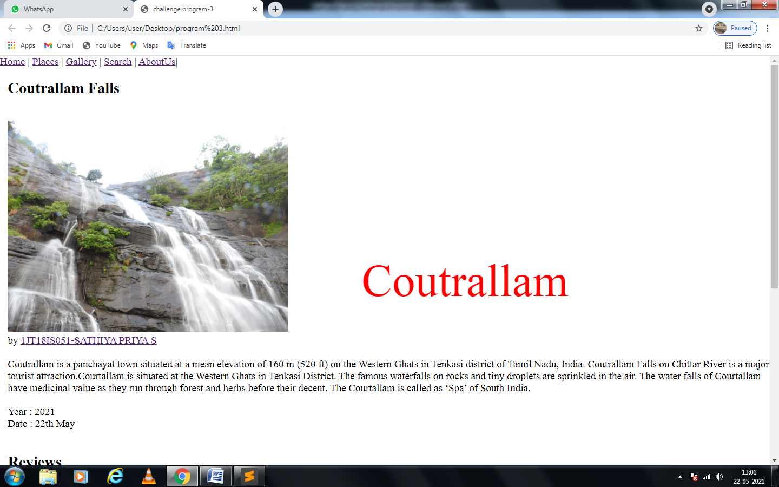

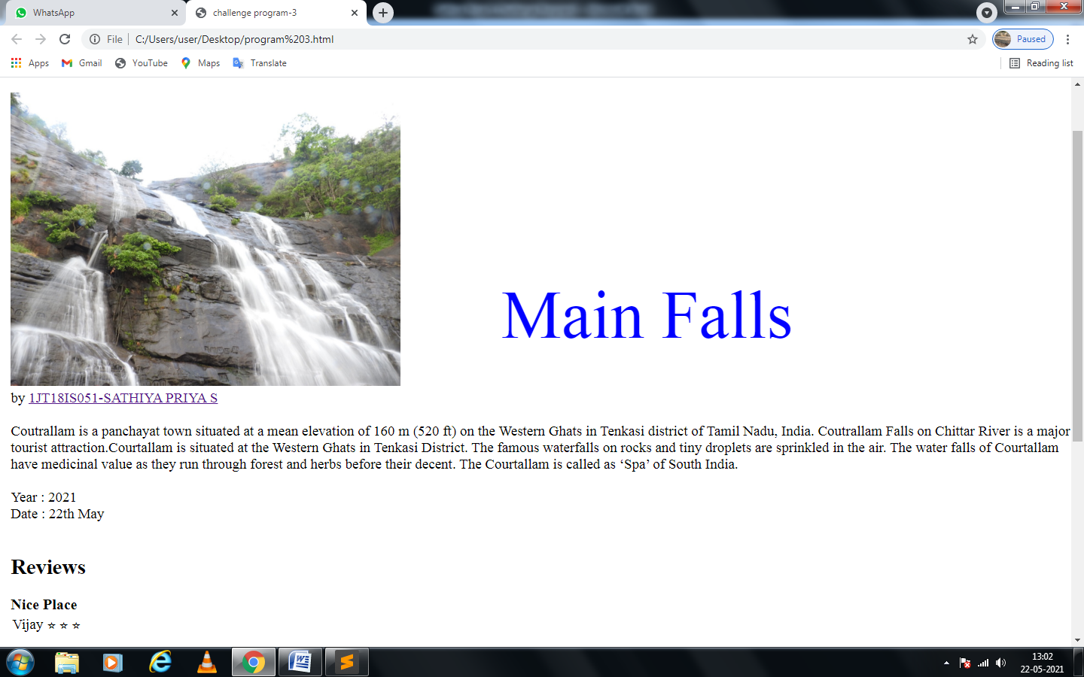

SATHIYA PRIYA S (1JT18IS051)

